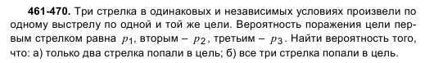
№467
P1=0.5, p2=0.7, P3=0.8.

